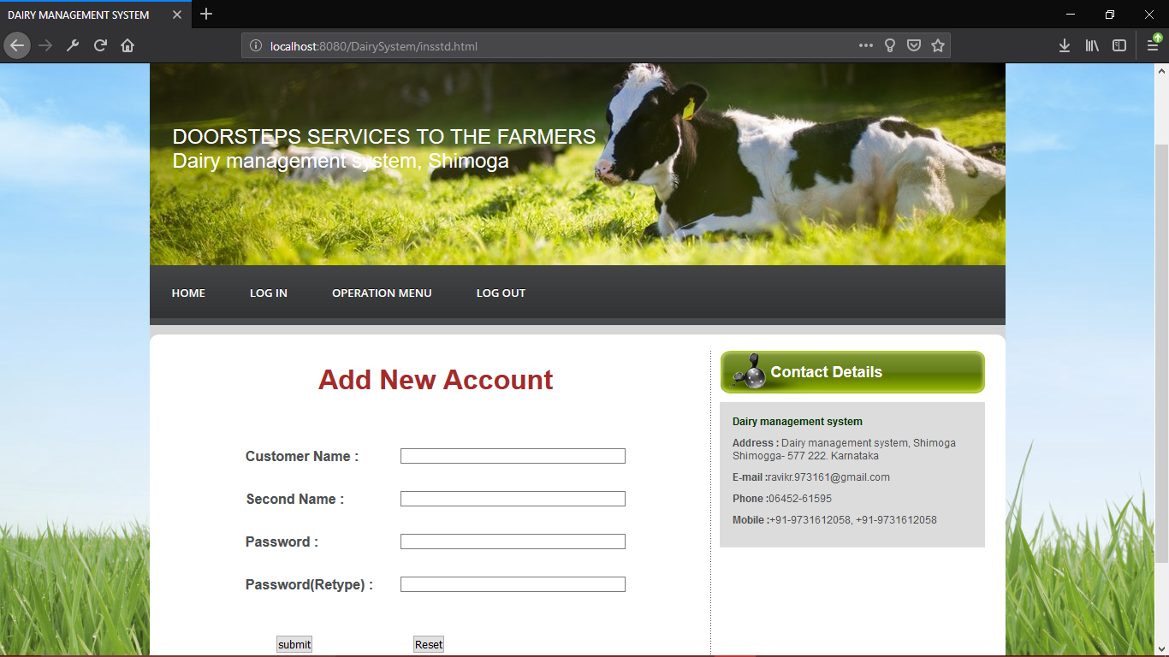

**Fig4.3: Registration Page for users**

Figure 4.3 shows Registration page for the new user the details of user is filled in the registration page (New Account).

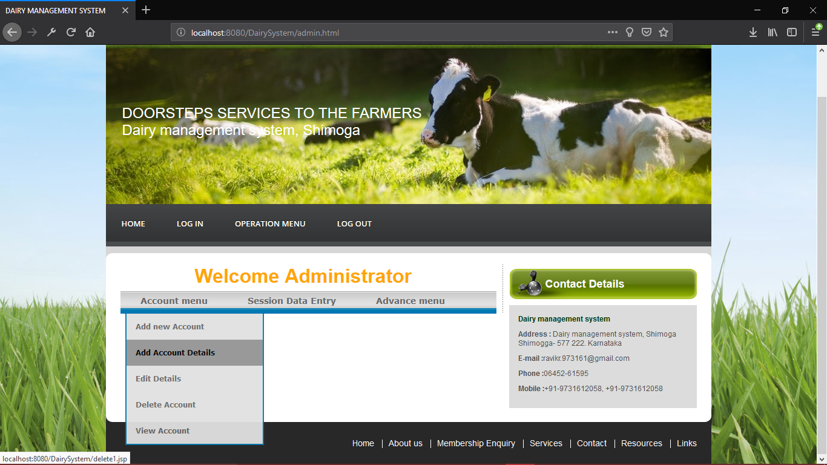

**Fig 4.4: Administrator Page**

Figure 4.4 shows Administrator operation menu from which all the operations are performed

by admin.

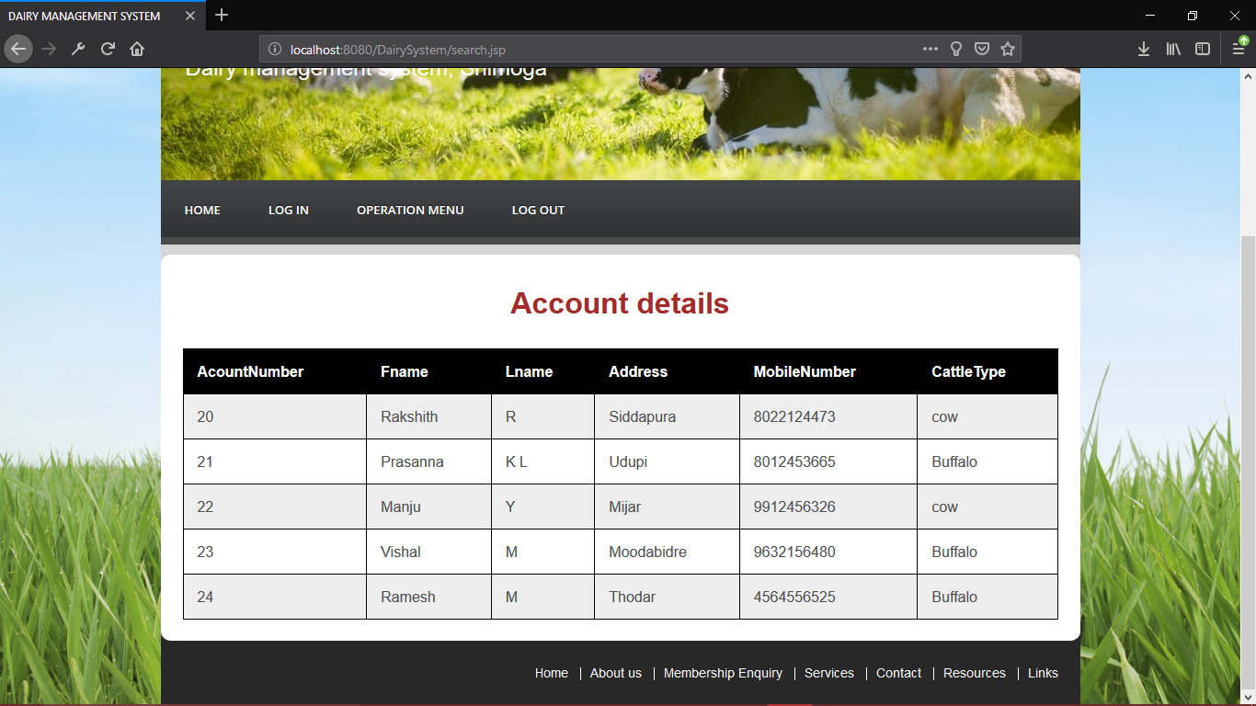

**Fig 4.5: Account details.**

Figure 4.5 showsActive available Account details in the Dairy system.

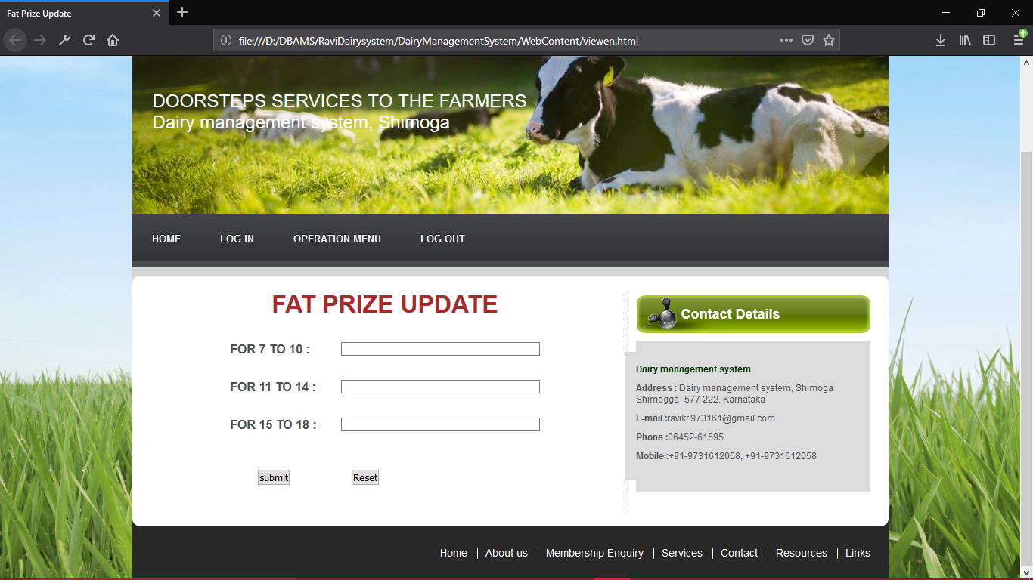

**Fig 4.6: Fat price setting**

Figure 4.6 showspage which is used to update prize of the milk.

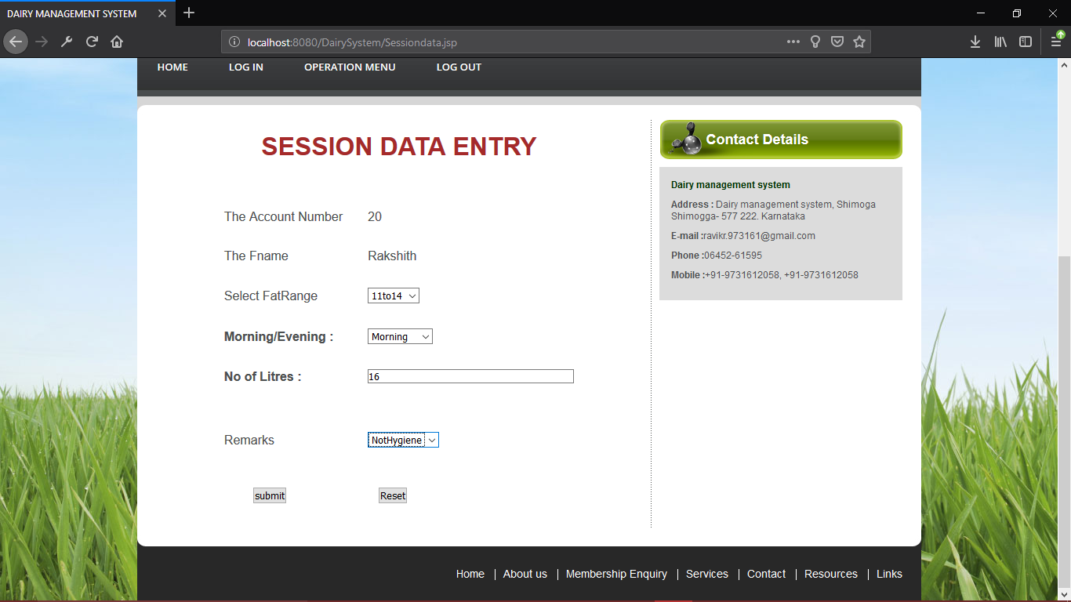

**Fig 4.7: Session Data Entry**

Figure 4.7 shows session data Entry page for the user is filled by the admin.

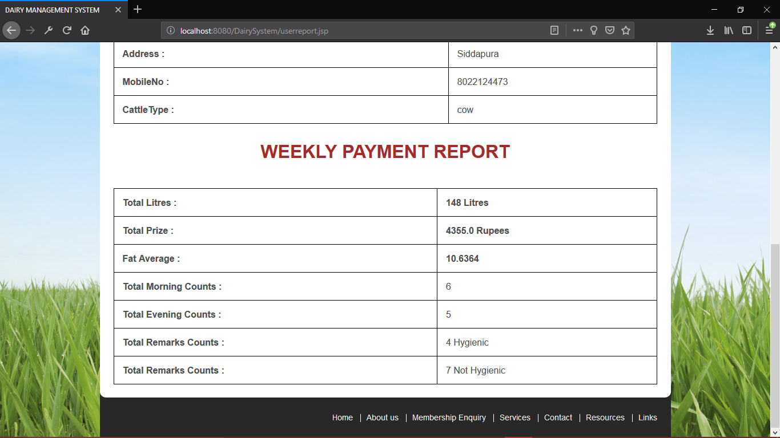

**Fig 4.8: payment Report generation.**

Figure 4.8 shows payment Report generation it is done by the Admin.

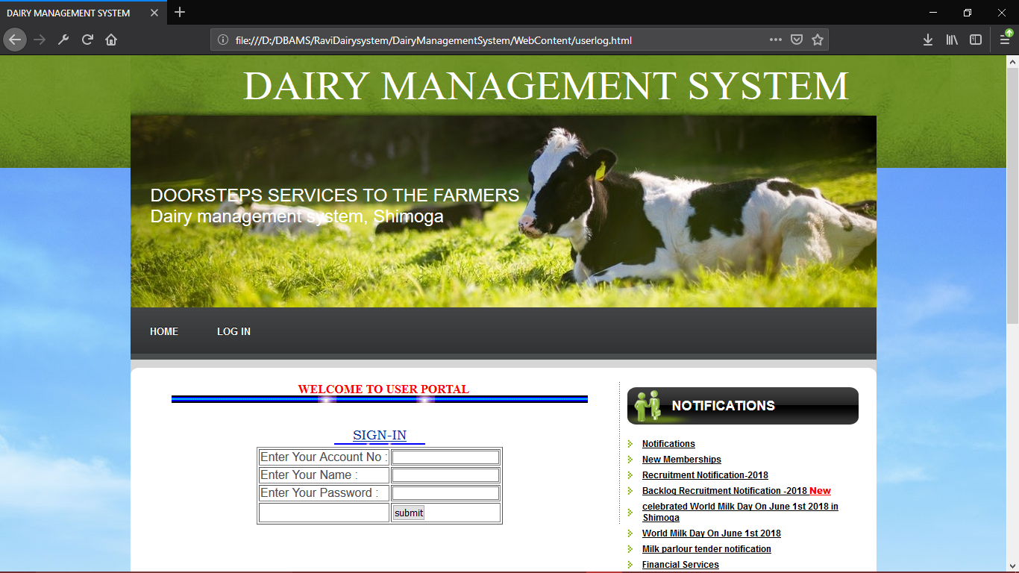

**Fig 4.9:User login portal**

Figure 4.9 shows user Login portal of the Dairy management System.

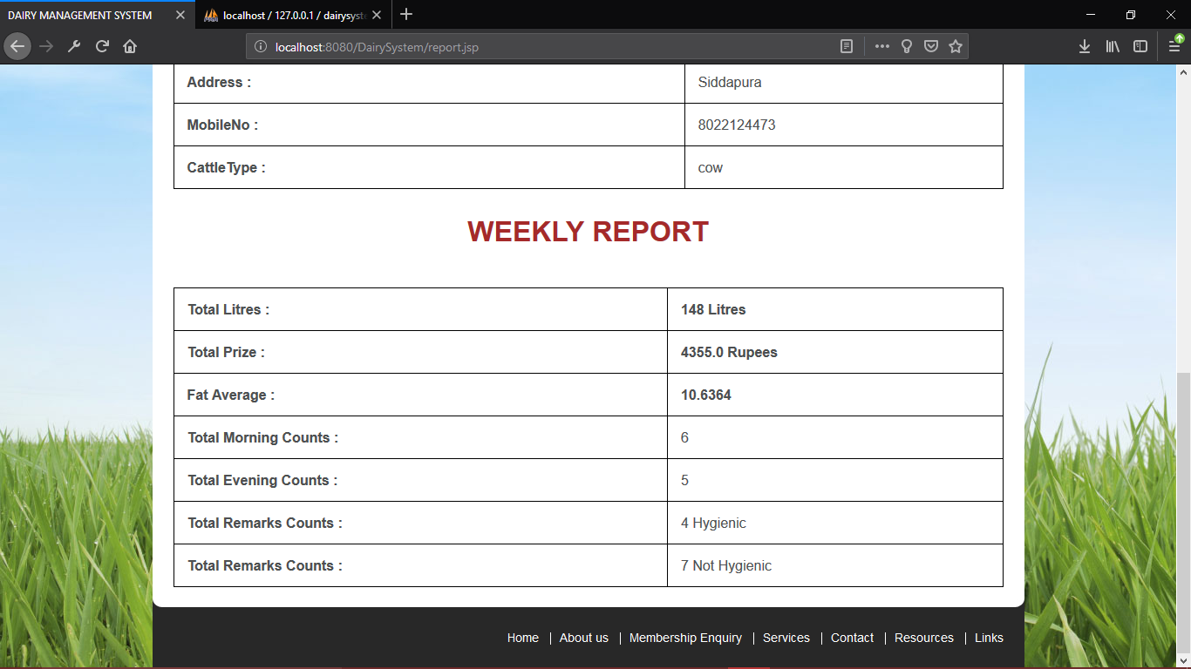

**Fig 4.10: Weekly Report generation.**

Figure 4.10 shows Weekly Report generation it can be generated by the user.

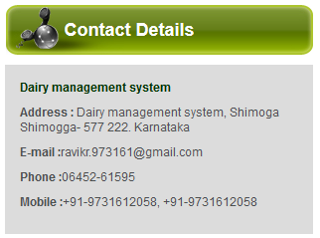

**Fig 4.11: Contact Us**

Figure 4.11 shows Contact us page to contacting admin phone number and address is given in this page.